**NETWORK SECURITY FUNDAMENTALS**

**CASE STUDY**

Family Name: David Selvam

Given Name: Visahl Samson

Student Number: 10498743

Unit code and Title: CSI3207 Network Security Fundamentals

Name of Lecturer: Loh Kah Yee

Campus: PSB Academy, Singapore

Course: Bachelors of Science in Cyber Security (FT)

Due Date: 22nd November 2019

Contents

Task 1 – Configuring Firewall using iptables 3

Firewall configuration 3

Vulnerability assessment 7

Task 2 Webserver Hardening 10

Task 3. Issues with current network design 13

Issue 1 – Usage of Single Layer 2 Switch 13

Issue 2 All the servers are connected directly to the switches 13

Issue 3 No network segmentation 13

Issue 4 Usage of Single firewall 13

Task 4. Improved Network Design 14

Configuration details 14

Effectiveness of the proposed design 15

Task 5. Internet Usage Monitoring Policy 16

5.1 Internet Monitoring 16

5.2 Internet filtering policy 16

5.3 End-user responsibilities 17

References 18

# Task 1 – Configuring Firewall using iptables

Assuming that the news agency using a single layer 2 (i.e. Datalink layer) network switch to connect all its devices which include their PCs, Web Server, Proxy and File Server. The network range here is 192.168.33.0/24. Whenever the internal user wants to access their internal services i.e FILE SERVER, Web server the traffic goes through their switch. Since the webserver serving to external users and connected to the same switch it can possibly expose the internal systems to the external users. So here the Ubuntu will be acting as a firewall/router that will filter the traffic.

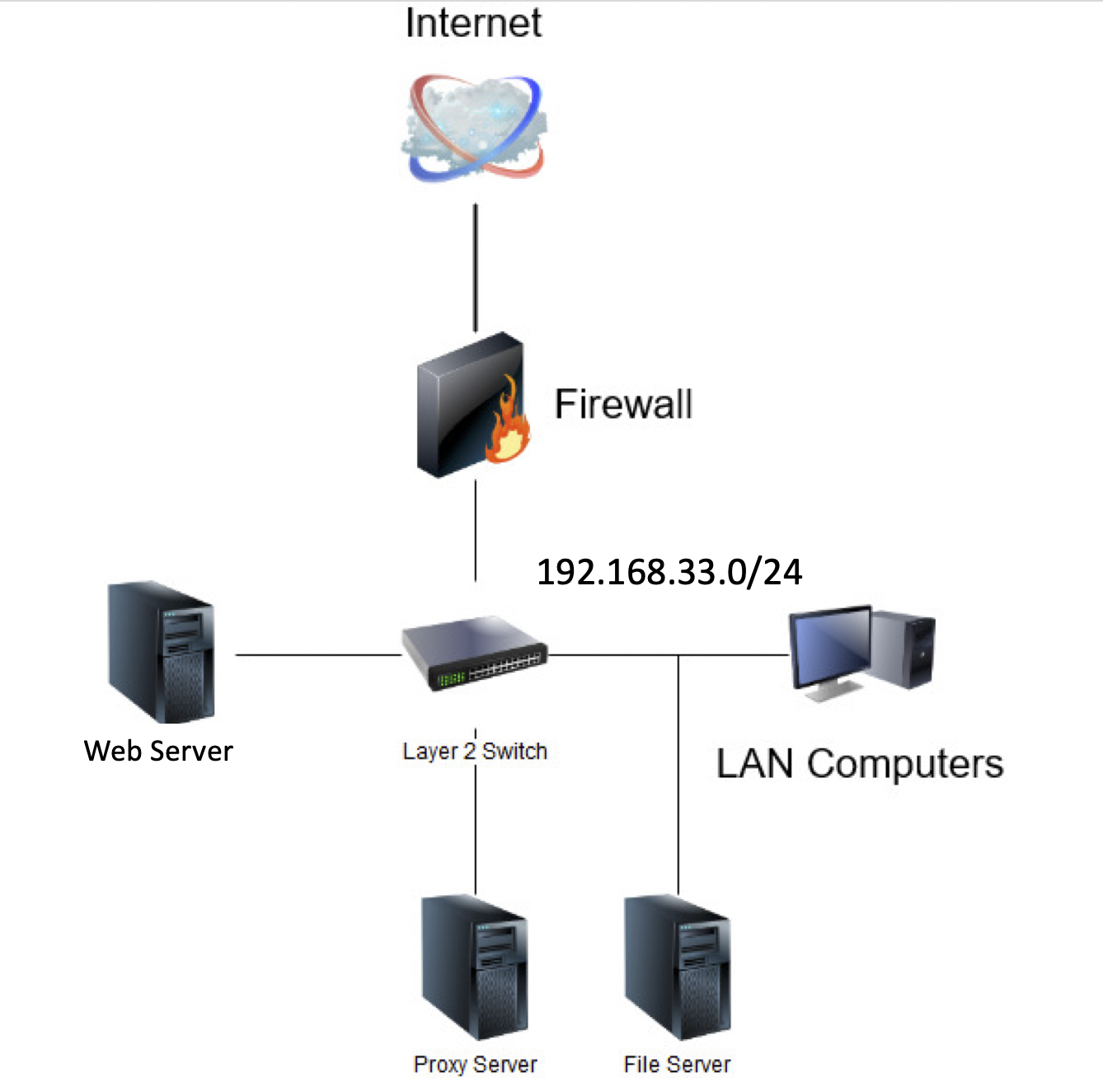

Figure 1 Given network configuration

Since the network is 192.168.33.0/24 based on, the webserver IP assigned as 192.168.33.4.

## Firewall configuration

For configuring the firewall we require 2 NIC’s. One is to deal with internal and another one is to deal with external. So for the internal interface, the IP address is 192.168.33.11 and the external interface would be at the different range which is 182.168.92.143.

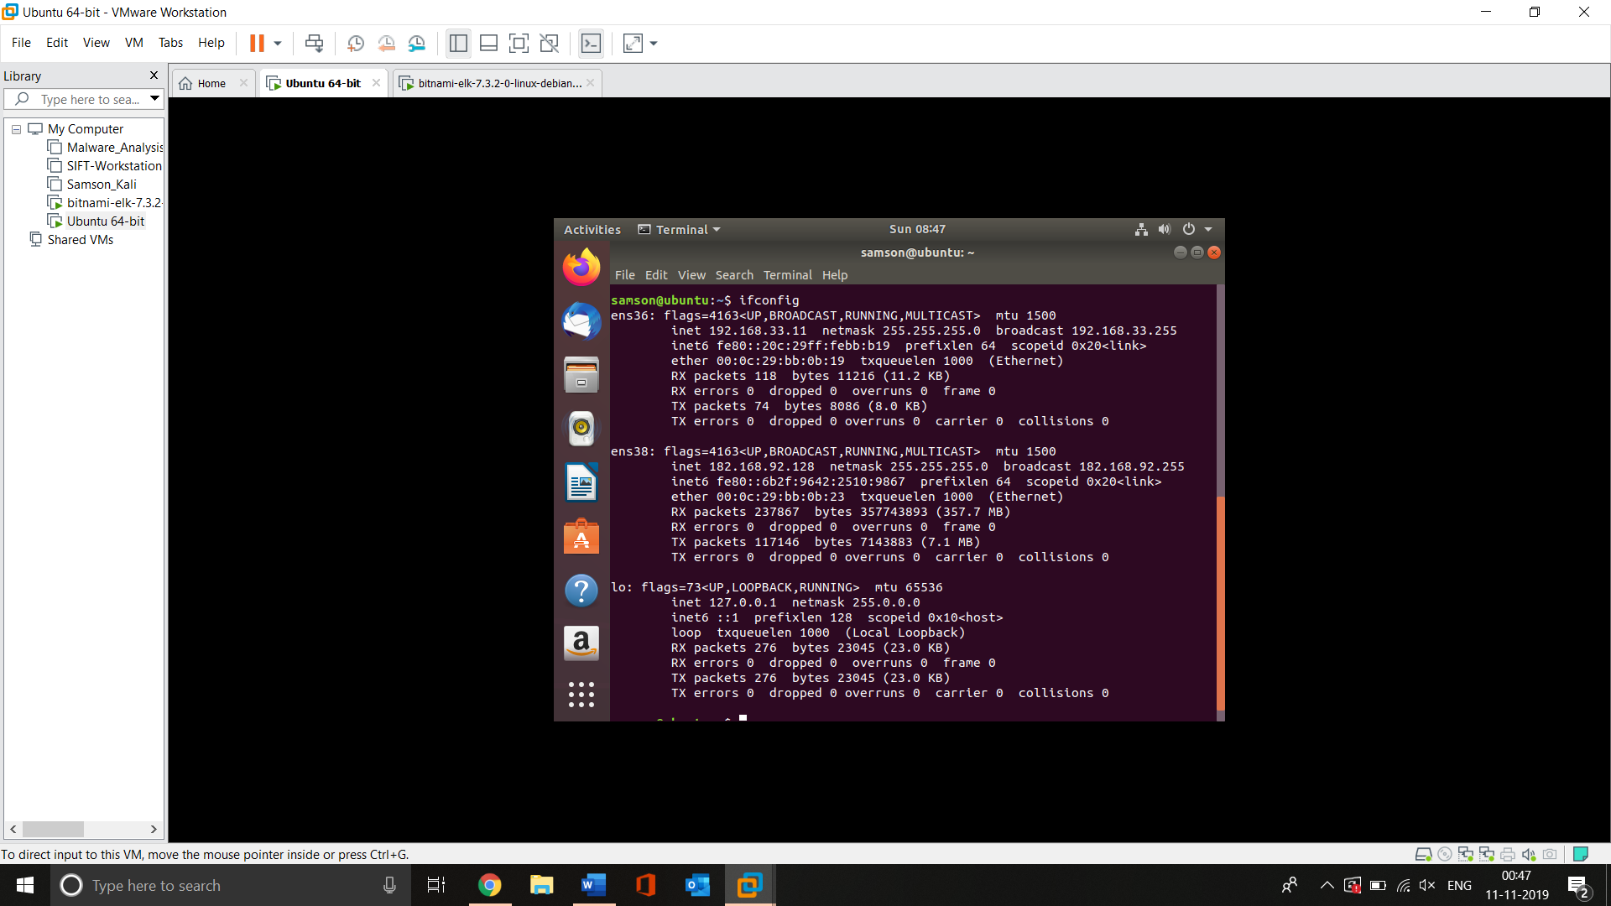

Screenshot 1 IP Configuration

The above screenshot shows the IP configuration for both the network interface where ens36 is for internal and ens 38 is for external.

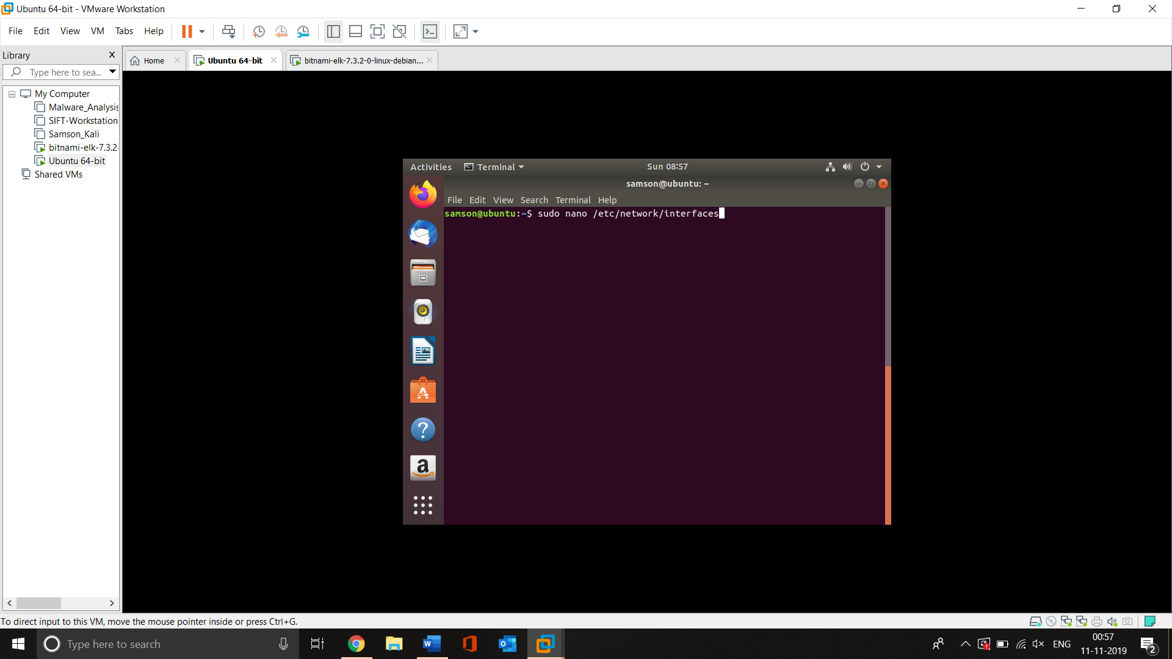

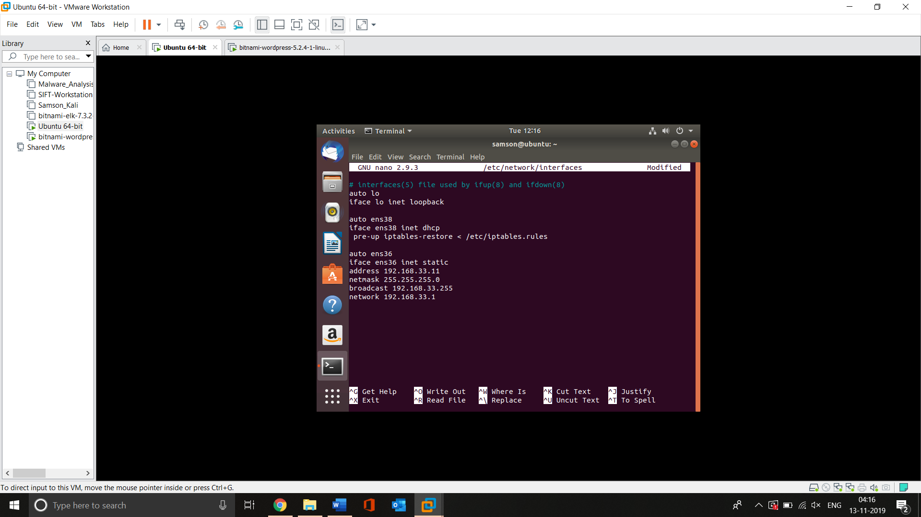

Screenshot 2 Opening Network interfaces file

Above screenshots shows the usage of command **sudo nano /etc/network/interfaces** to open the network interfaces files in Editor and have added the command **auto ens38 iface ens33 inet dhcp pre-up iptables-restore < /iptables.rules** that use to enable the external interface 38 to act as DHCP server for the connections that are coming from external users. And the remaining commands use to map the internal interface with its relevant netmask and network.

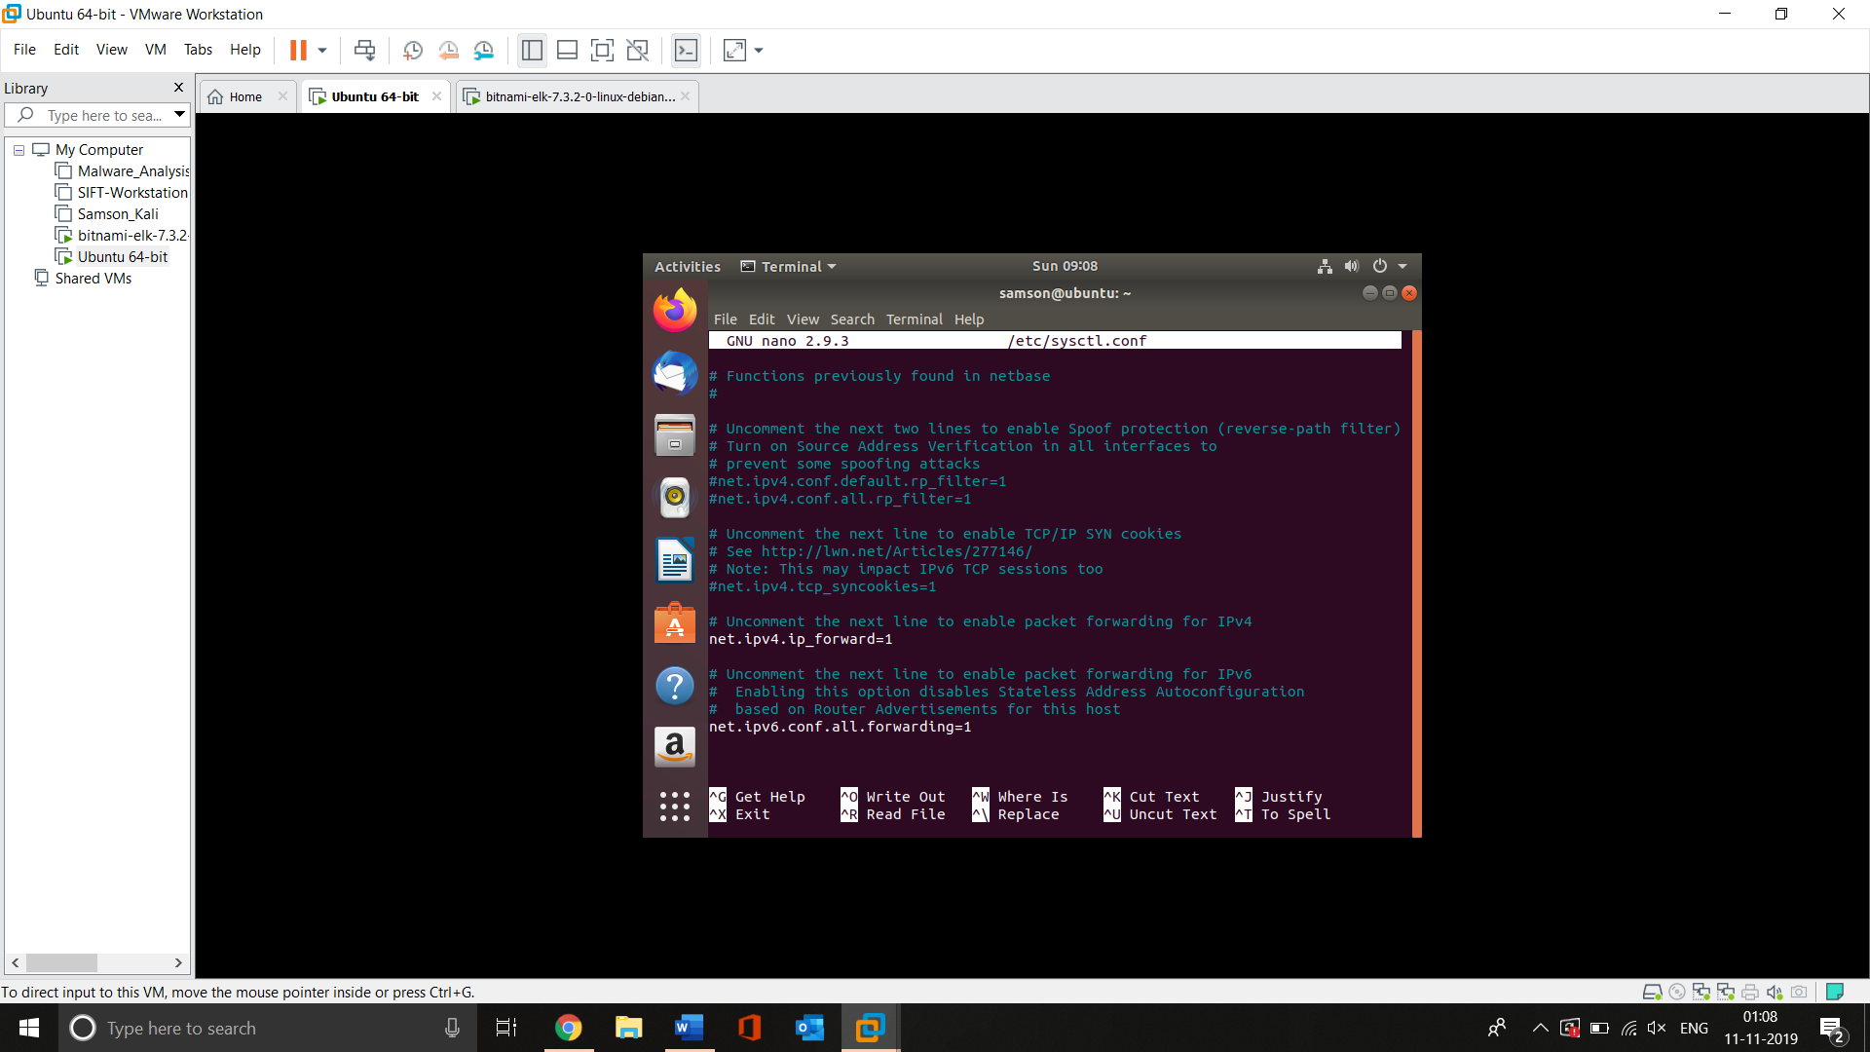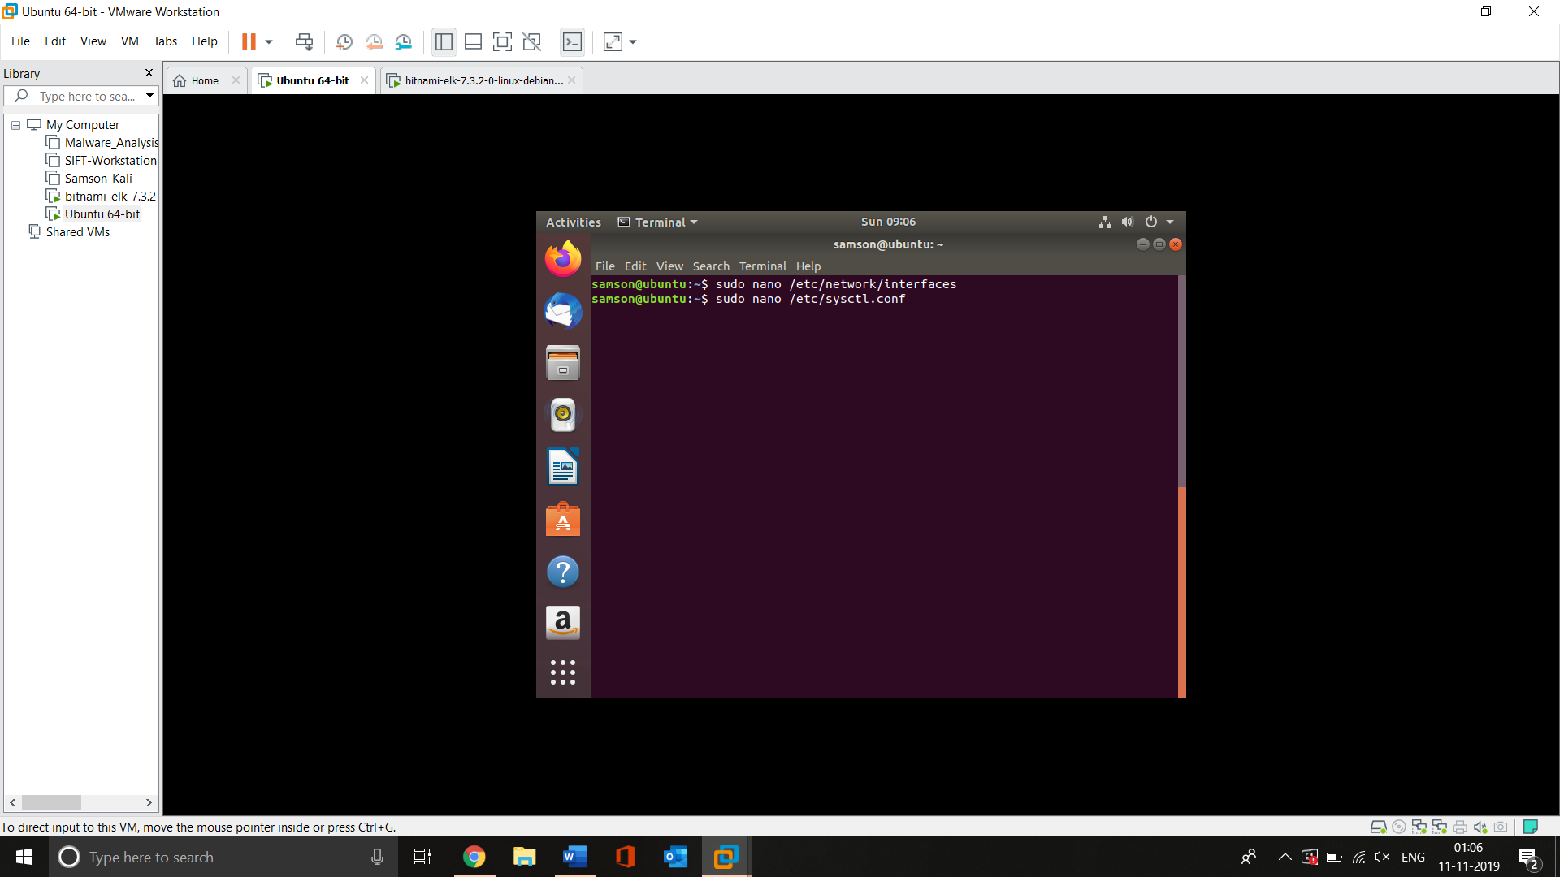

Screenshot 3 Enabling the routing

Screenshot 3 shoes the usage of command **sudo nano /etc/sysctl.conf** that helps to open the sysctl.conf file that helps to change the parameters dynamically in Linux. Once the file opened I uncommented the line **net.ipv4.ip_forward=1** that enables the system to route the IPv4 traffic between external and internal interfaces.

**Iptables**

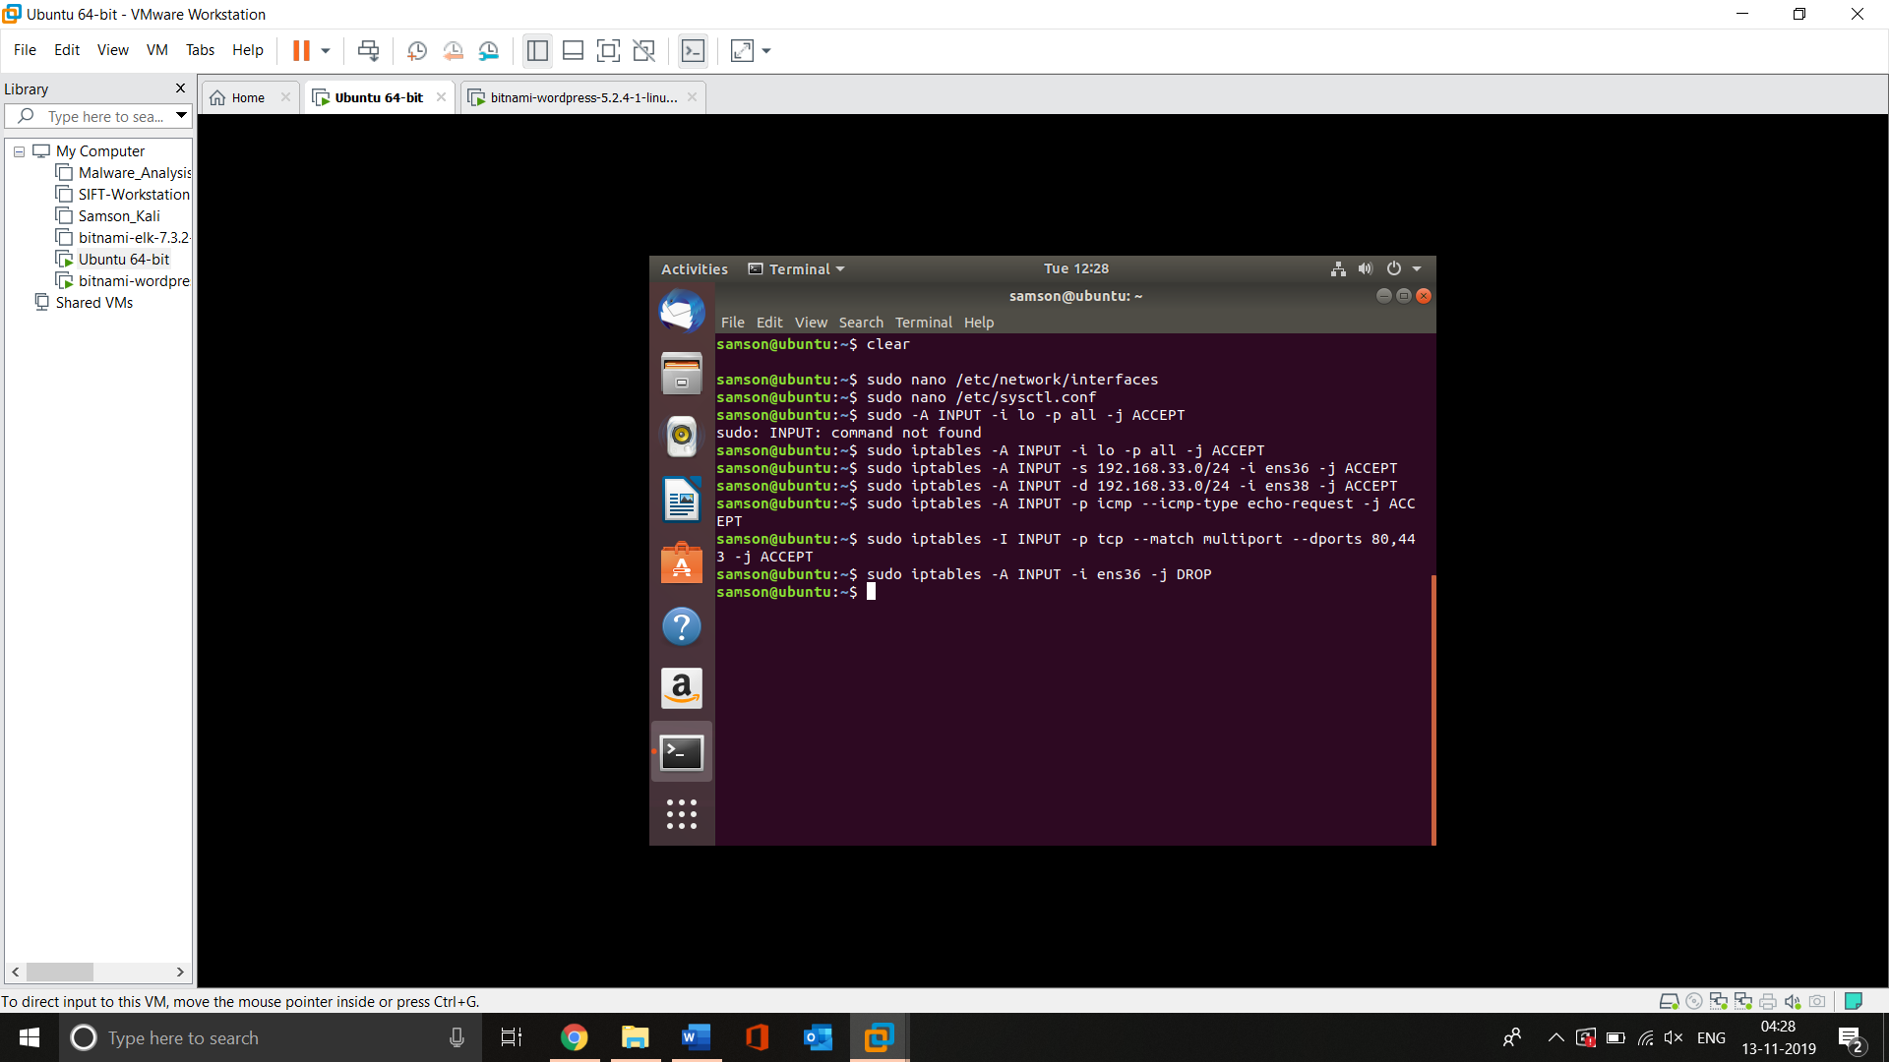

Screenshot 4 Configuring INPUT chain

The above-given screenshot shows the setting-up process of INPUT chain. The commands used here allowes the firewall to accept the traffic and route them. Command **sudo iptables – A INPUT -I ens36 – DROP** configuring the firewall to drop all non-http and non-https traffic.

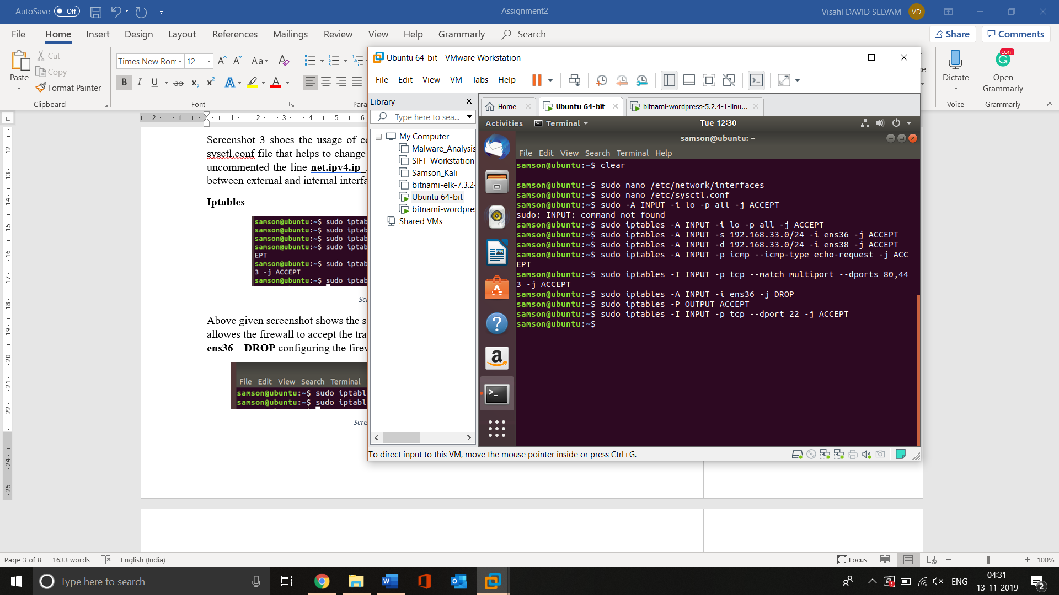

Screenshot 5 Configuring OUTPUT Chain

The above screenshot elucidates the setting-up process of OUTPUT chain when the command **sudo iptables -P OUTPUT ACCEPT** allows the firewall to allow all the output traffic to pass through.

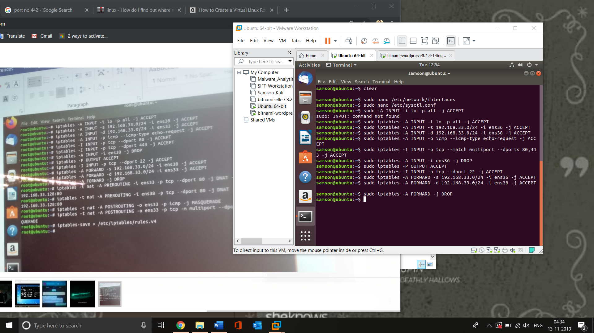

Screenshot 6 Configuring FORWARD Chain

Screenshot 6 shows the setting-up process of FORWARD chain where the commands indicate the firewall to forward the traffic from internal network to external interface and all the remaining transfer would be dropped.

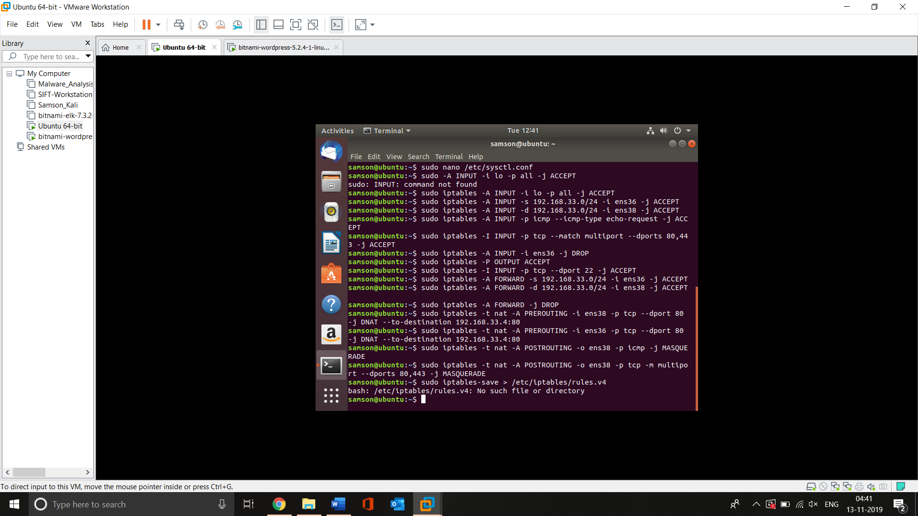

Screenshot 7 Configuring NAT operations

The above-given screenshot shows the configuration of nat operations in firewall which enables it to transfer the traffic between different networks.

## Vulnerability assessment

In order to do the Vulnerability assessment, I have used Kali Linux. The tools I used include NMAP, Nikto, and WPscan. The test results have been given below

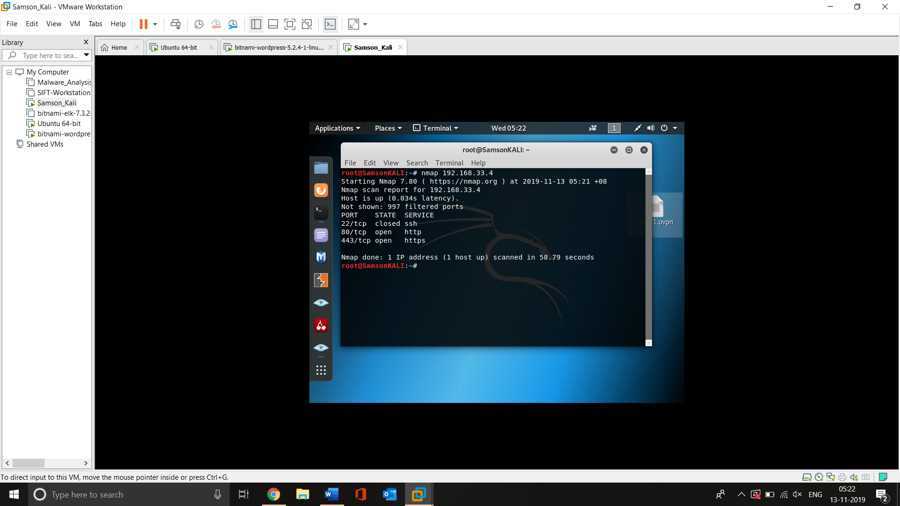

Screenshot 8 NMAP Scan

The above-given screenshot shows the basic NMAP scan results. The command used here is **nmap 192.168.33.4** which permits the nmap to perform scanning on the given IP address (in here its 192.168.33.4).

As we can see in the screenshot the http and https ports are open which allows the external users to access the webserver.

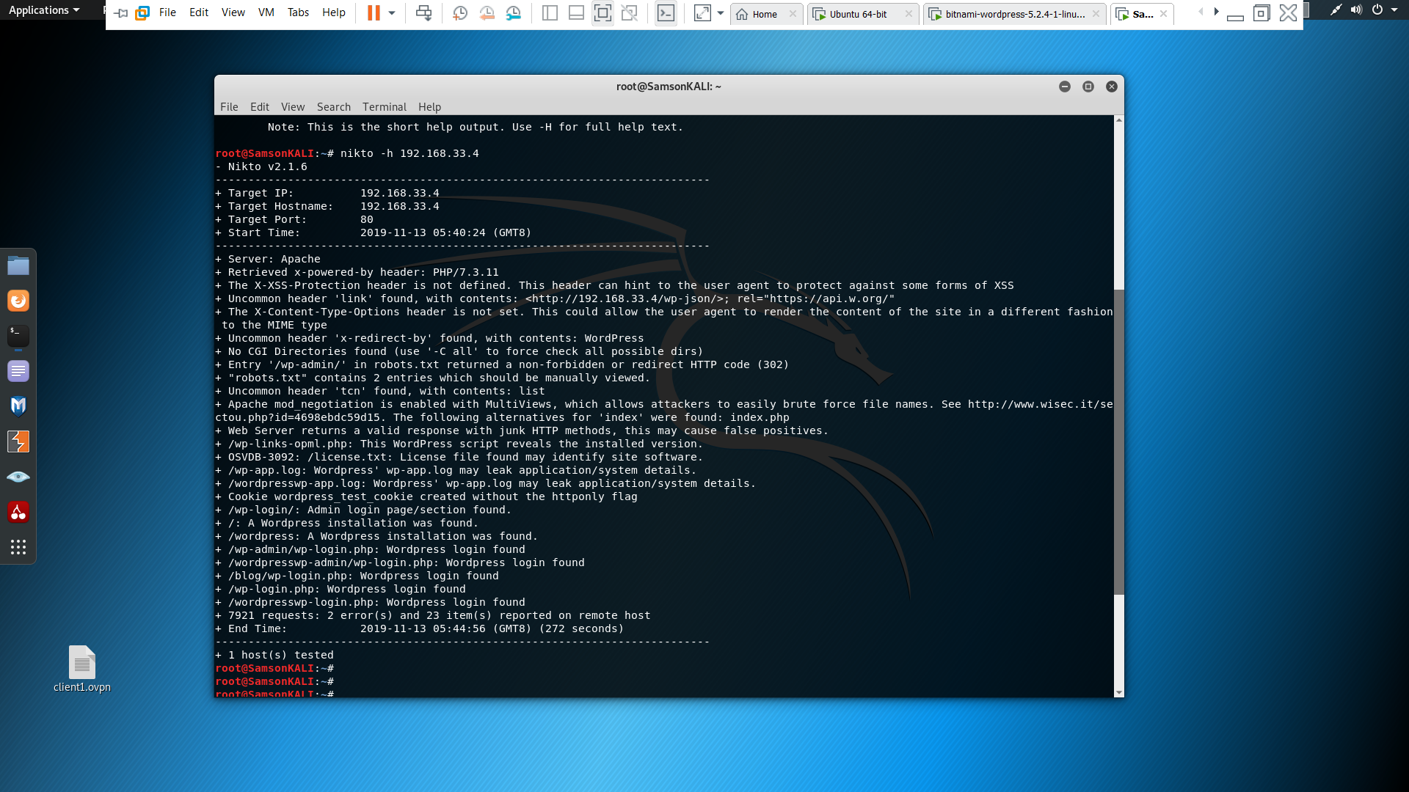

Screenshot 9 Nikto scan

Above screenshot 9 elucidates the usage of Nikto scanner to perform vulnerability assessment. I have used Nikto to perform scanning on the webserver. The command used here is **nikto -h 192.168.33.2** which enables Nikto to perform scanning on the given web server. As we can see in the screenshot it displays all the possible web application vulnerabilities.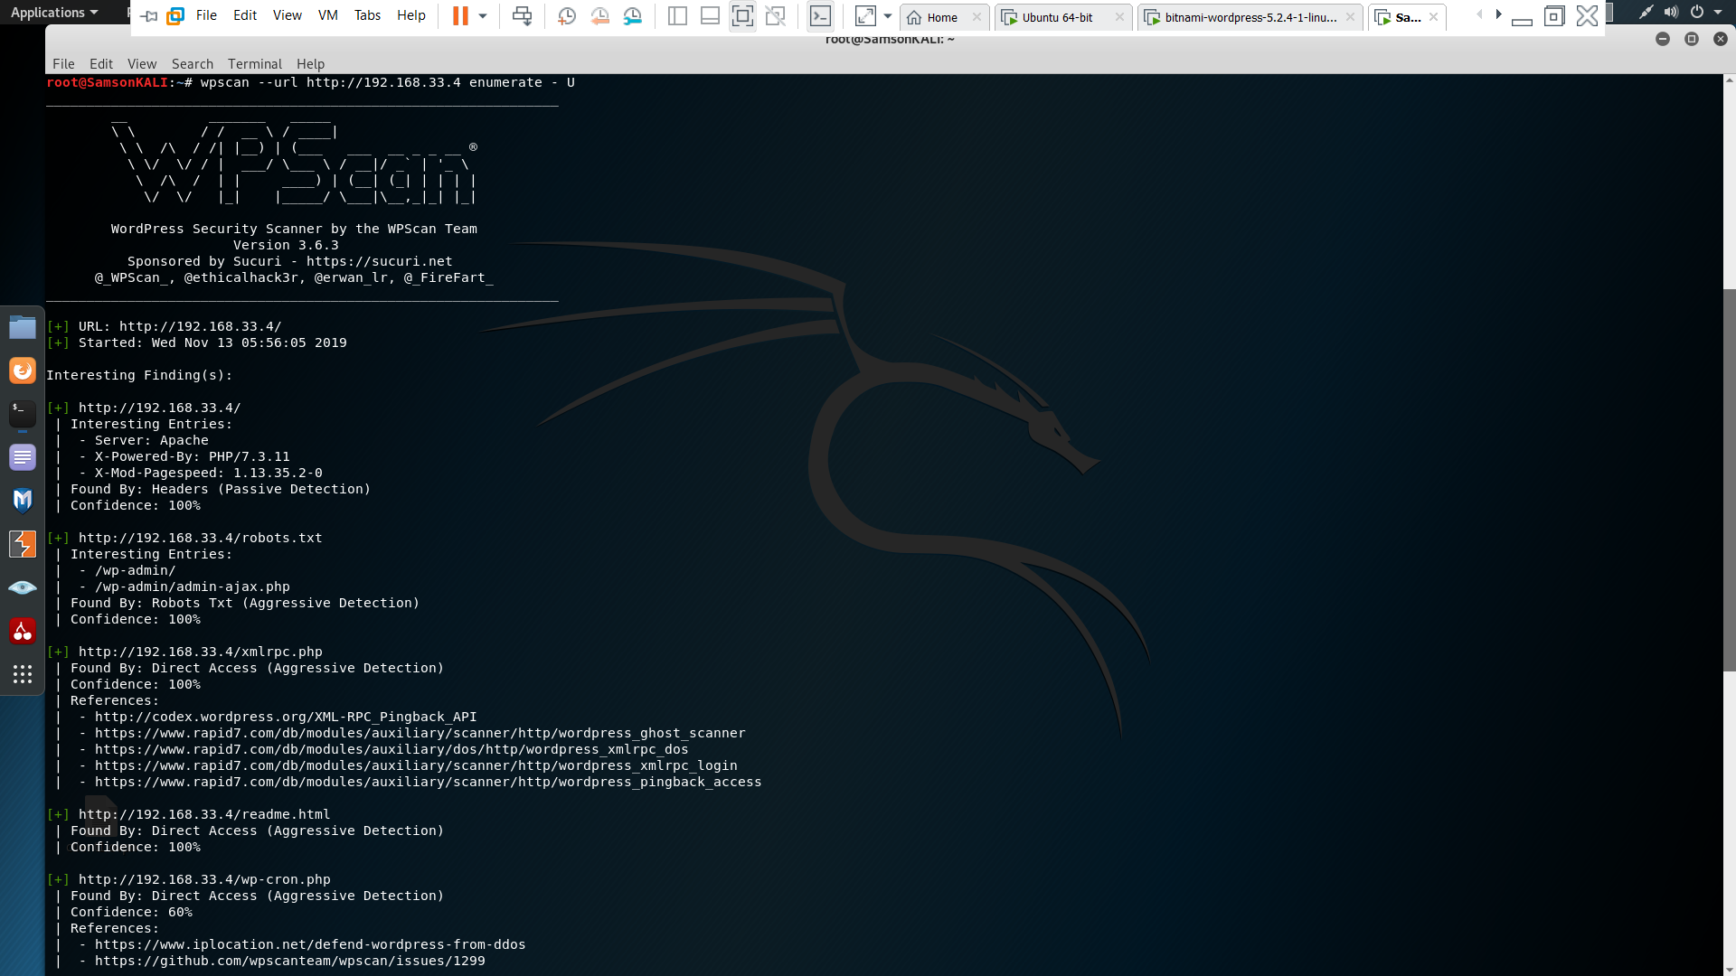 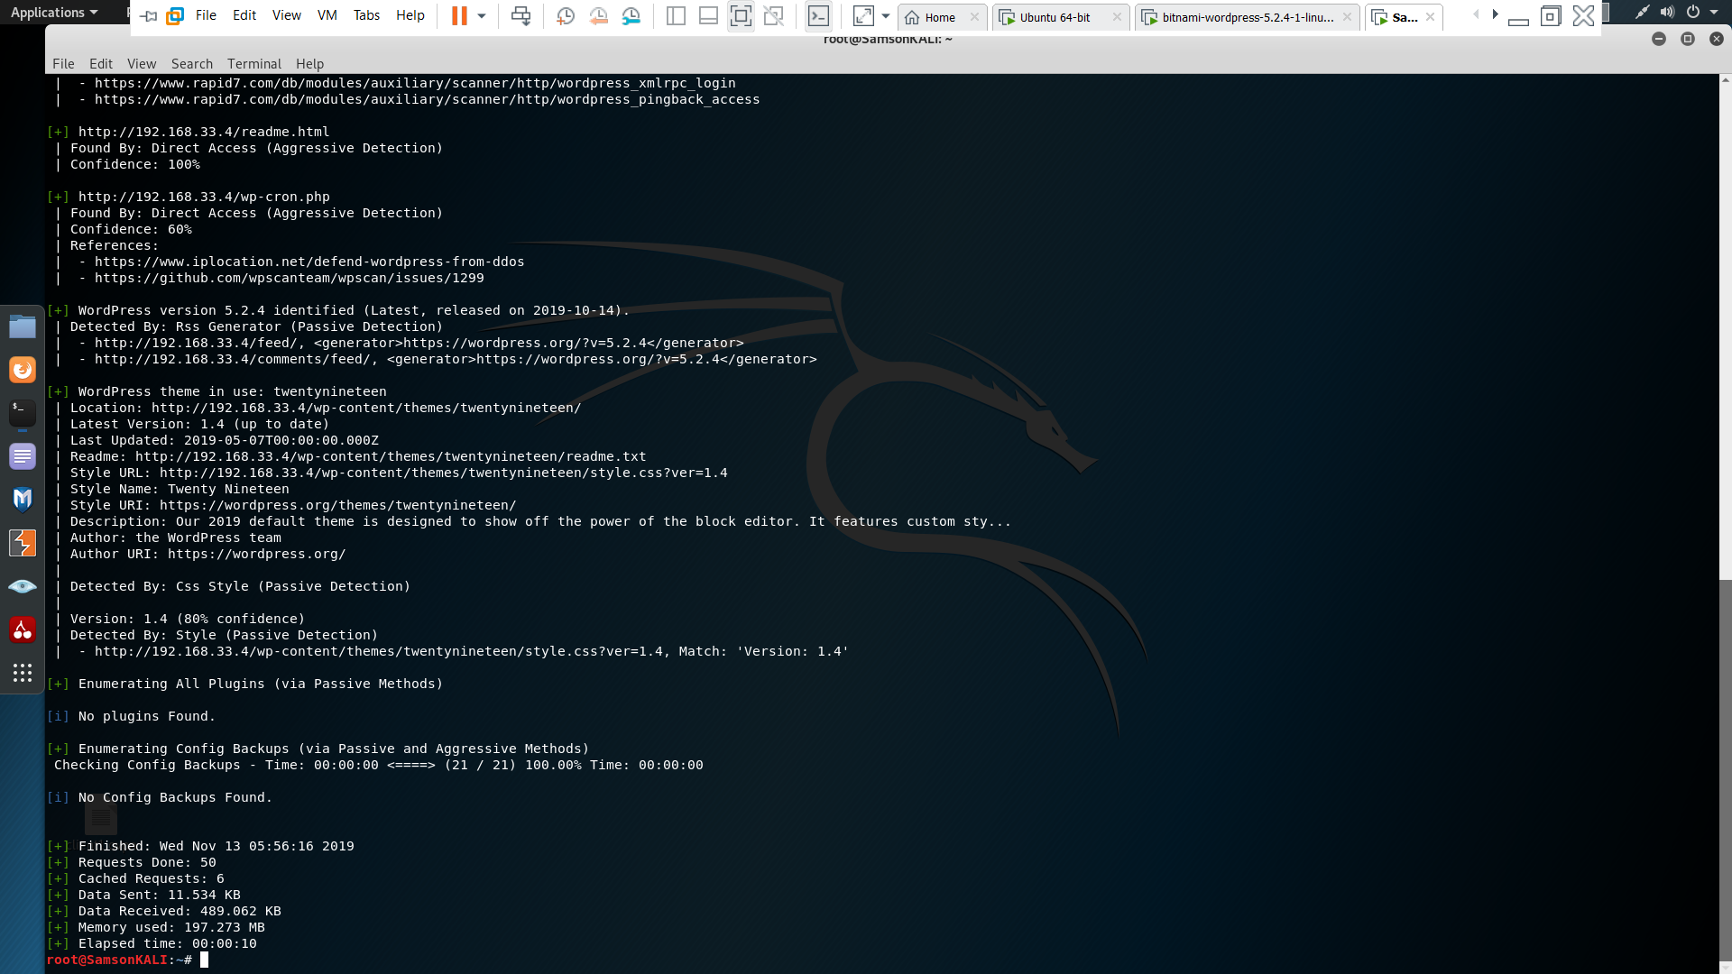

Screenshot 10 WPscan

Screenshot 10 shows the usage of WPscan to scan the web application. The command I used here is **wpscan –url** [**http://192.168.33.4**](http://192.168.33.4) **enumerate – U** where this command runs WPScan on the web application and displays all the enumerated plugins, themes from the given web application.

# Task 2 Webserver Hardening

During the Vulnerability assessment, it became clear that the webserver has enough security measures with the use of iptables.

In order to harden it, I have implemented Snort. It is basically an Intrusion Prevention System that can perform real-time traffic analysis (Snort.org, 2019).

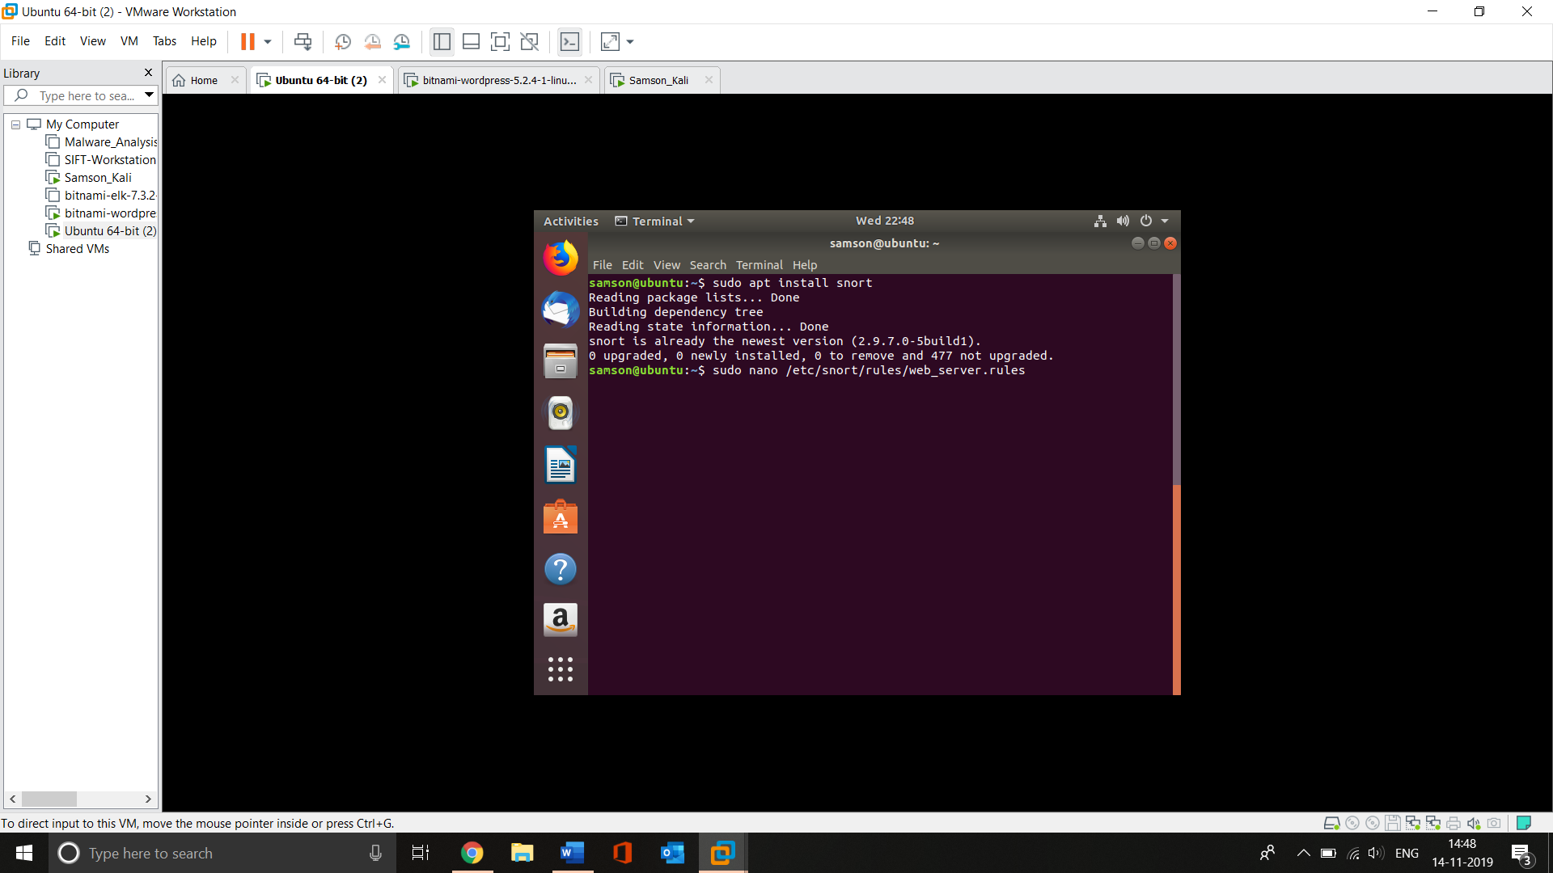

Screenshot 11 Configuring SNORT

The above screenshot shows the usage of command **apt install snort** which will install the SNORT IPS. Then the command **nano /etc/snort/rules/web_server.rules** used to create a rule file named web_server.rules where it allows to add rules to monitor.

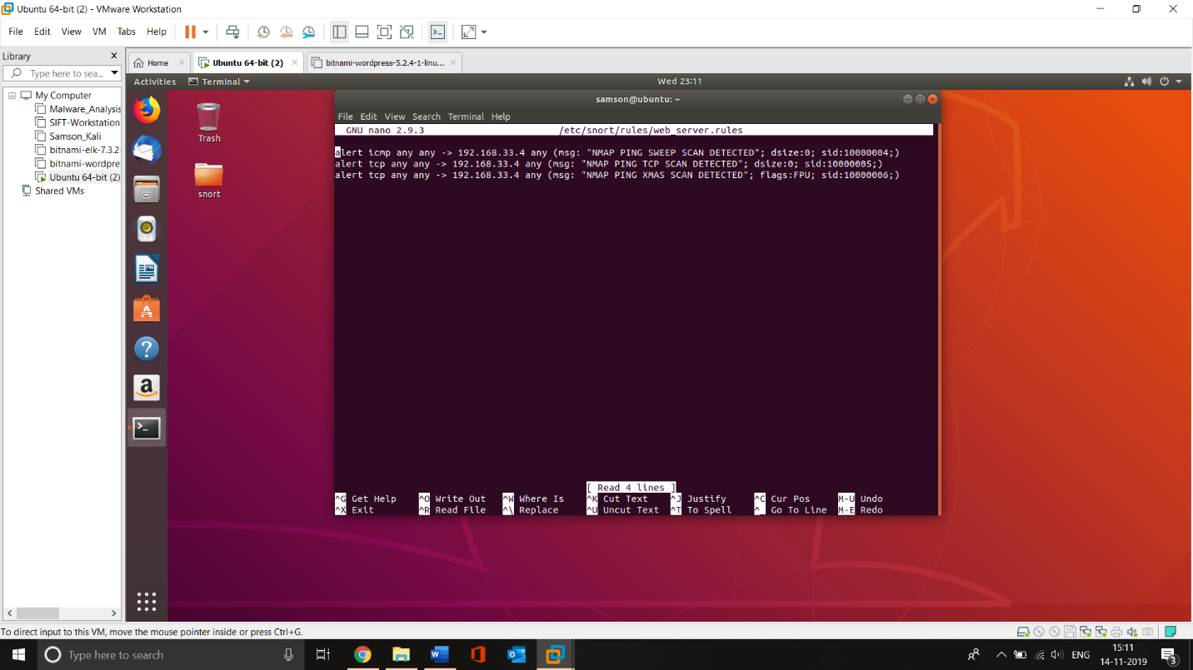

Screenshot 12 Adding Rules

Inside the rules files, for now, I have added 3 rules which will alert 3 types of NMAP scans such as Ping sweep, TCP scan, and XMAS scan. The command used here **alert icmp any any -> 192.168.33.4 any (msg: “NMAP PING SWEEP SCAN DETECTED”; disize:0 sid:10000004; )**

**Icmp stands** for the protocol **any any which stands** for traffic from any ip and any port **192.168.33.4 any** where 192.168.33.4 is web server ip address and any stands for any port on webserver**. Msg** stands the text that it should display**.** And **sid:1000004** is rule id number

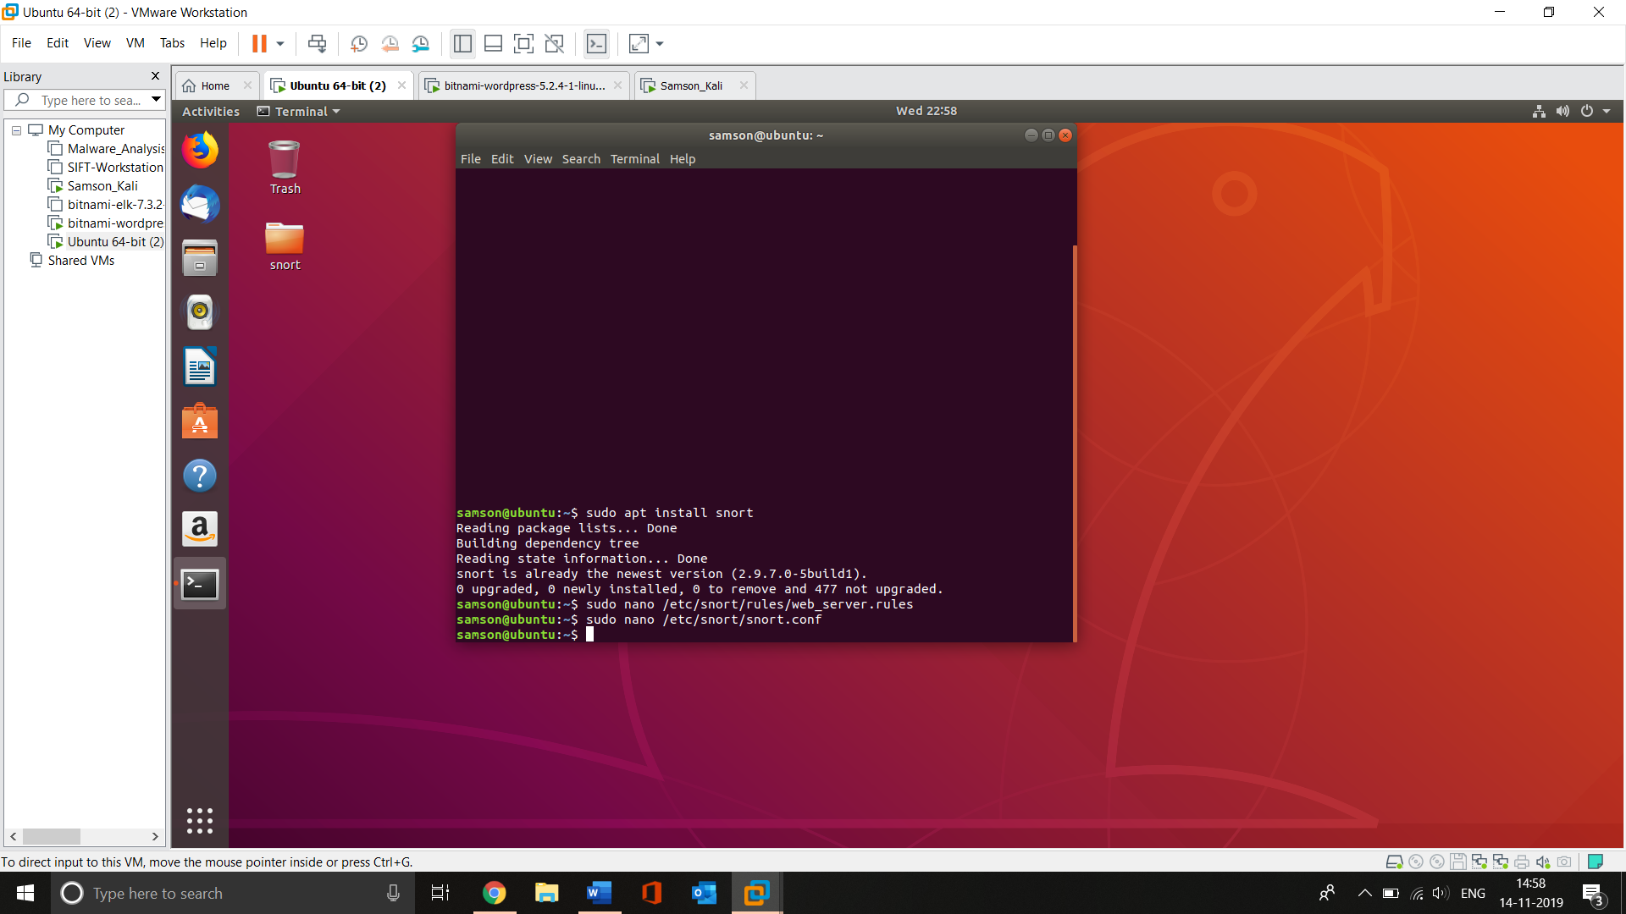

Screenshot 13 Modifying SNORT configuration

Screenshot 13 shows the usage of command **nano /etc/snort/snort.conf** which allows modifying the snort configuration file. Once I entered the command I got the configuration file in the editor and added **include $RULE_PATH/web_server.rule** that allows SNORT to perform based on the rules provided in the rules file. The screenshot is given below.

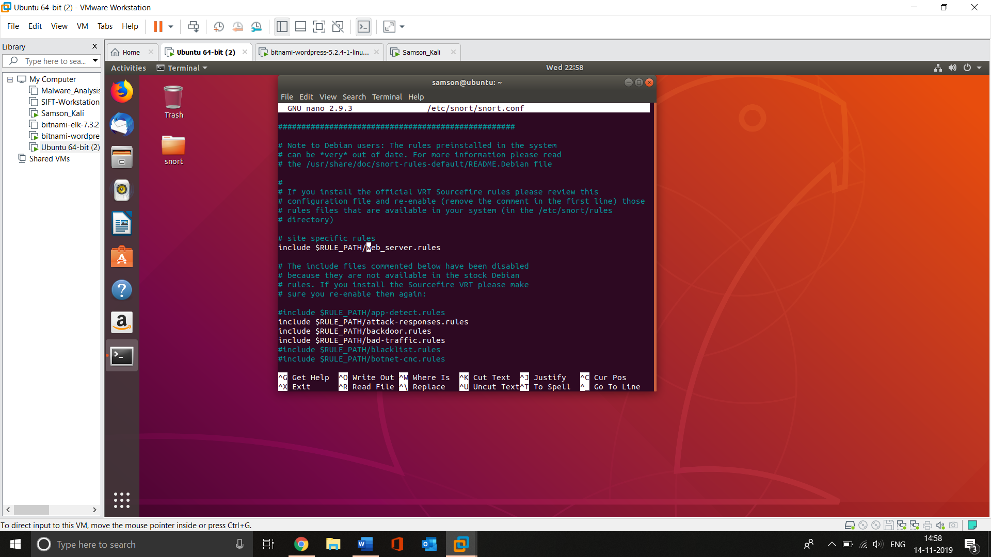

Screenshot 14 Adding specific rules to SNORT

Once the rules are added I used the command **snort -l /var/log/snort -b -c /etc/snort/snort.conf** which will log the SNORT activity.

Once everything is done I have started SNORT on external interface (i.e ens38) by using the command **sudo snort -A console -q -c /etc/snort/snort.conf -i ens38.** The screenshot is given below.

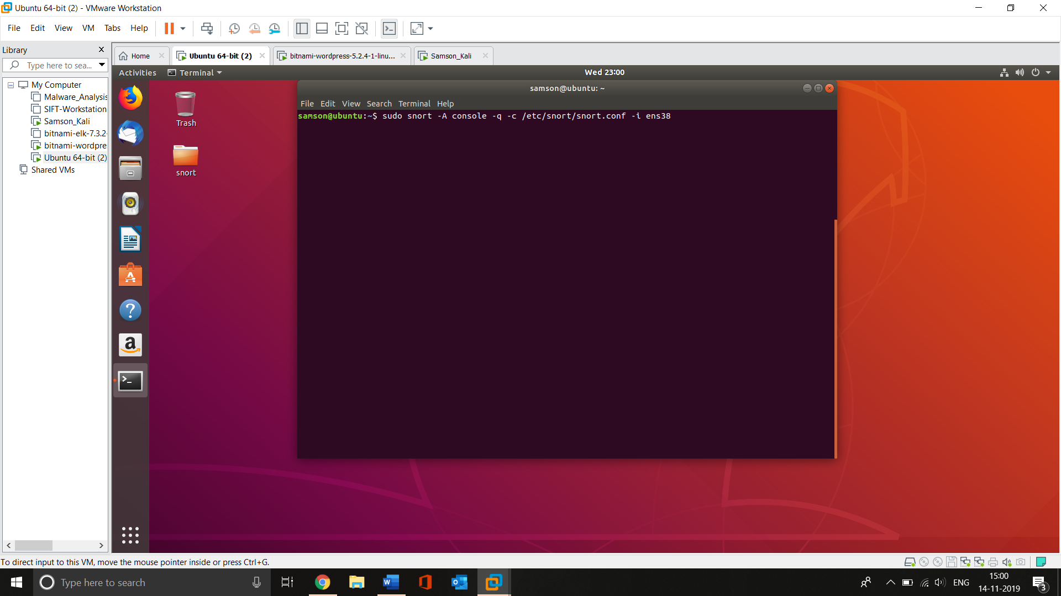

Screenshot 15 starting SNORT

After starting SNORT on interface ens38 I used NMAP to perform an ICMP scan on webserver with the command nmap -sP 192.168.33.4 –**disable-arp-ping** where the syntax disable-arp-ping used to send specifically ICMP packets to the target. The screenshot is given below.

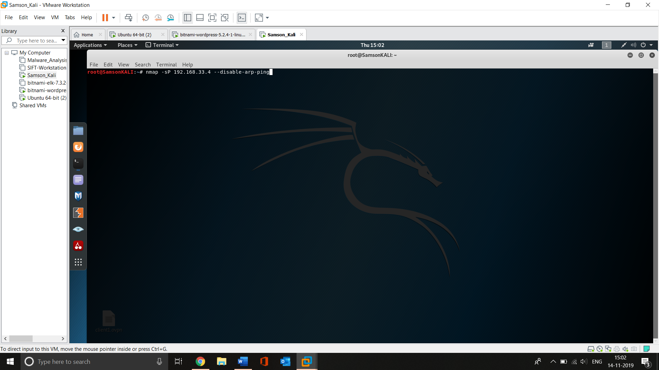

Once the NMAP scan started SNORT started to display the alert.

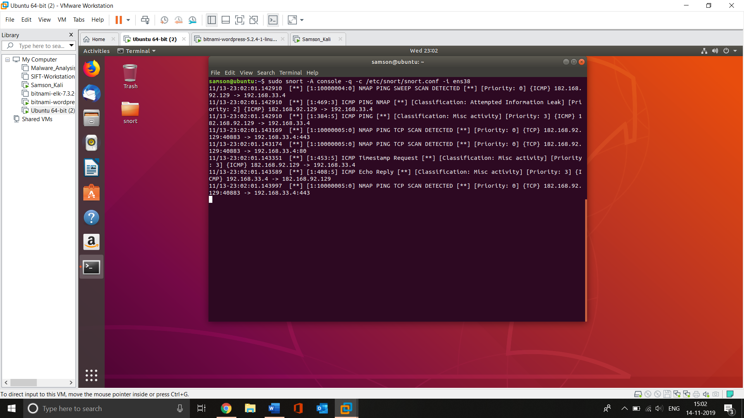

Screenshot 16 Detection in SNORT

Screenshot 16 shows the detection of SNORT IPS of the ICMP packets. Where it displays rule id 10000004, alert message, source IP 182.168.92.129, and Destination IP 192.168.33.4

Also, the event logs will be stored in SNORT directory which will allow to view them later.

# Task 3. Issues with current network design

## Issue 1 – Usage of Single Layer 2 Switch

All the devices are connected here with the help of Layer 2 switch (i.e. Datalink layer). Using Layer 2 switch at this point to connect the server is not encouraged. Because there are several security attacks can be performed on Layer 2 Switch which includes MAC Attacks, ARP Attacks, VLAN “Hopping” attack, STP (Spanning Tree Protocol) attack, DHCP starvation stacks,

Basically, (Spiceworks, 2014) in layer 2 switches anything that transmitted by one device will be transmitted to all other devices that are connected to the switch which cause-effect in QOS (Quality of Service).

## Issue 2 All the servers are connected directly to the switches

As given in assumptions all the webserver, proxy and File Servers are connected through the same switch. Since web server should be accessible to the external users it puts proxy and File Server in risk. Due to this configuration, the organization’s internal/confidential data will become accessible to external users.

Also, in general, it’s recommended (Mike, 2012) to keep the internal servers into DMZ where the servers cannot be accessed by the outside of the network.

## Issue 3 No network segmentation

In current network design, all the devices are coming under the same network (i.e 192.168.33.0/24) where if one system is compromised it leads to the exploitation of other devices. The best example of these kinds of incidents is Target Data Breach (Shu, Ke, Andrew & Danfeng (Daphne), 2017) happened in 2013. Where the malware infected one POS and since, all the devices are connected in the same network the Malware spread all over the network and resulted in one of the biggest data beaches (Aaron, 2019) in the world.

To overcome this issue it’s recommended to configure VLAN where the Systems will be separated from the rest of the devices in the network.

## Issue 4 Usage of Single firewall

In the current design, only one firewall is used where it performs as a shared resource between an internal and external network (Ullrich, 2014). This single firewall configuration for this network design has few issues. Firstly, the network includes servers so in general it’s recommended to use DMZ for the server where the network will be placed with 2 firewalls but here only a single firewall is given also no DMZ zone is provided.

Secondly, Since the single firewall acts as a shared resource DOS attack on the firewall from the WAN (external) interface will affect the LAN (Internal) resources which lead to deviation in QOS (Quality of Service).

# Task 4. Improved Network Design

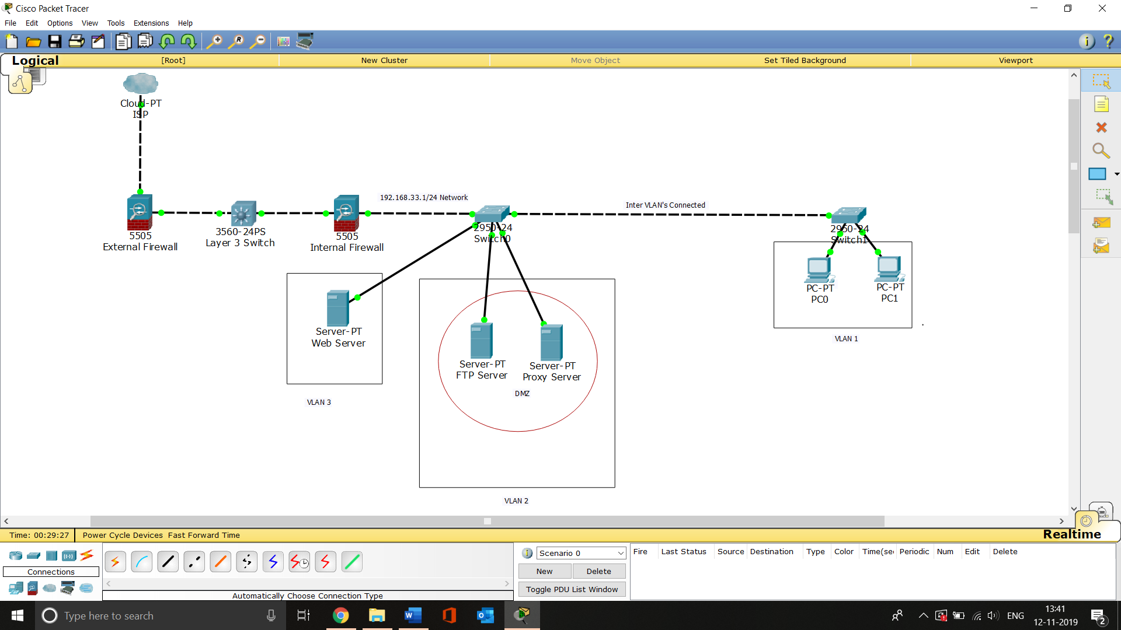

Screenshot 17 Improved Network Design Diagram

### Configuration details

**Hardware**

No of firewalls – 02

Layer 3 switch – 01

Layer 2 switch – 02

Server – 03

PC - 02

**Function**

Firewall 01- External Firewall

Firewall 02 - Internal firewall

Layer 3 Switch – Route the traffic

Layer 2 Switch 0 – 2 VLAN (VLAN 3 for the Web server, VLAN 2 for DMZ with Proxy and File Server)

Layer 2 Switch 1 – 1 VLAN (VLAN 1 for the Devices inside the company)

DMZ – Inside VLAN 2 for Proxy and File Servers)

The above-given screenshot elucidates the improved network design diagram designed using Cisco Packet Tracer Software. In this configuration, the traffic comes from external to access web server will first come to the external firewall once it filtered it will be routed by the Layer 3 switch to the internal firewall and pass to the switch then go to VLAN 3 web server. While the traffic goes out from Web server to the external users the process flow will be the same. Also, when the internal users need to access the FILE SERVER, the Proxy server they can access them from VLAN 1.

### Effectiveness of the proposed design

The proposed design can eliminate all the issues listed previously. The briefs for the issues are,

**Issues 1 –** Previously all the devices connected through a single layer 2 switch whereas in the proposed design Layer 3 switch has been used to route the traffic. The purpose of using layer 3 switch here is to simplify the security management (Lavanya, 2018) and as well as to provide high-speed scalability. Also, it supports inter VLAN routing.

**Issues 2 –** Previously all the Proxy, Web and File Servers connected directly into the switch now in the new design the servers are divided and kept into DMZ and VLAN. Also, as given in requirement the external users who want to access the webserver can be routed to the VLAN 1 where they can not access FILE SERVER or Proxy servers.

**Issue 3 –** Earlier all the devices and servers came under a single network where compromising one device lead to exposure of the entire network. In the new design, the entire network is divided into 3 VLANs using 2 Switches so now the issues can be avoided.

**Issue 4 –** In this new design 2 Firewalls have been added where one is for the incoming traffic and another one is for outgoing traffic. In this configuration, the internal resources/devices can be safer from DOS. Also, the implementation of DMZ will increase the security for the FILE SERVER and Proxy servers.

# Task 5. Internet Usage Monitoring Policy

In general, the internet usage policy is used to provide the employees of an organization with the proper usage company network, internet access, and devices (GFI, 2019). The advantage of internet usage policy is if an employee uses the internet access to access something that he/she not supposed to access and if it mentioned in the policy then under this circumference the internet usage policy will reduce the business risks as an outcome of employee fault.

## 5.1 Internet Monitoring

IT department will monitor internet usage from all the devices such as Desktop/Laptop PC,etc.. that are connected to the organization network (Sans, 2019).

The traffic monitoring system will lodge the following attributes,

* Source IP
* MAC address
* Data and time
* Protocol used
* Destination IP/address

The lodged record will be maintained for 180 days which is recommended (Sans, 2019).

## 5.2 Internet filtering policy

The IT department shall block access to all the protocols and websites that violate the state, local, or federal law or the equivalent or interfere with the organization’s mission and vision. Protocols and websites that come under the following categories will be blocked

* Advertisements & Pop-Ups
* Adult/Sexually Explicit Material
* Chat and Instant Messaging
* Gambling
* Hacking
* Illegal Drugs
* Peer to Peer File Sharing
* Personals and Dating
* Social Network Services
* SPAM, Phishing and Fraud
* Spyware
* Offensive Content
* Violence, Intolerance, and Hate

## 5.3 End-user responsibilities

* All the employees and users must obey all state, federal, and local laws.
* All the employees and users must obey all appropriate copyright laws and perhaps bear responsible for any violations.
* All the employees and users must obey all kind of license agreements which includes legal restrictions of use and copy.
* Using the organization's IT resources for personal commercial purposes or personal economic advantage is now tolerable.
* Using IT resources in order to gain unauthorized access to any whatever is not allowed.
* All the employees and users must only use the equipment, services, password, and accounts for which they have authorization.
* All the employees and users must not intentionally render useless, or damage, any date, software, or equipment.
* The employees and users should not allow unauthorized users to gain access to IT resources. This includes sharing login credentials for any accounts, or services where only they have authorization.

# References

What is Snort?. (2019). Retrieved from, <https://www.snort.org/faq/what-is-snort>

Spiceworks, I. (2014). Layer 2 or Layer 3 Switch??. Retrieved from, <https://community.spiceworks.com/topic/443034-layer-2-or-layer-3-switch>

Mike, C. (2012). Four Tips for Securing a Network DMZ. Retrieved from, <https://fedtechmagazine.com/article/2012/05/four-tips-securing-network-dmz-fed>

Shu, X., Ke, T., Andrew, C., & Danfeng (Daphne), Y. (2017). Breaking the Target: An Analysis of Target Data Breach and Lessons Learned, (rXiv:1701.04940v1). Retrieved from <https://arxiv.org/pdf/1701.04940.pdf>

Aaron, H. (2019). Hackers have become so sophisticated that nearly 4 billion records have been stolen from people in the last decade alone. Here are the 10 biggest data breaches of the 2010s. Retrieved from, <https://www.businessinsider.sg/biggest-hacks-2010s-facebook-equifax-adobe-marriott-2019-10/?r=US&IR=T>

Ullrich, S. (2014). Are two firewalls better than one?. Retrieved from, <https://security.stackexchange.com/questions/62213/are-two-firewalls-better-than-one>

Lavanya, R. (2018). What is a layer 3 switch and why would your network need it?. Retrieved from, <http://techgenix.com/layer-3-switch/>

GFI. (2019). Retrieved from, <https://www.gfi.com/pages/sample-internet-usage-policy>

Sans, .. (2019). Retrieved from, <https://www.sans.org/security-resources/policies/retired/pdf/employee-internet-use-monitoring-and-filtering-policy>